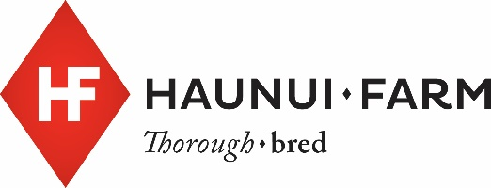
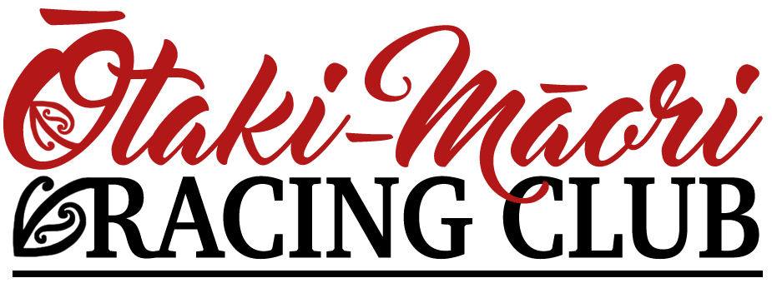

HAUNUI FARM GROUP ONE WFA CLASSIC | SATURDAY FEBRUARY 23rd 2019

An invitation to the Ōtaki-Māori Racing Club Members Brunch and the raceday to follow.
Brunch from 10:30am, racing from 12:30pm*

Tēnā koe e te rangatira,

The Ōtaki-Māori Racing Club warmly invites all Central Districts ex-trainers and ex-jockeys (and partners) as our special guests, to the annual Members Brunch prior to the Haunui Farm Group One WFA Classic Race Day, to be held on Saturday 23rd February 2019.

The event will offer a great opportunity for former jockeys and trainers to get together and reminisce about days gone by and share experiences of racing, not just at the Otaki track, but throughout the Central Districts.

Brunch will be followed by a great day of racing including what is traditionally one of the highest rated races in NZ, The Haunui Farm Group 1 Weight for Age.
The Haunui Farm Raceday provides the opportunity for us as New Zealand’s only Māori Racing Club to showcase the unique association between our culture and the Sport of Kings.
Arrival would be from 10:00am with brunch commencing at 10:30am with a mihi whakatau, welcoming all Ōtaki-Māori Racing Club members, special guests and their whānau, followed by a Members Brunch in celebration of our whakapapa, shared history and whanaungatanga.

There are eight races scheduled with the first being just after 12:30pm*.
We hope you can join us and ask that you RSVP attendance by 5:00pm Friday 15th February by emailing Ben at ben@otakimaoriracing.co.nz

We look forward to welcoming you to the 2019 Haunui Farm Group One WFA raceday.

Nau mai! Haere Mai! Tautoko Mai!

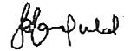

Rangi Ransfield
PRESIDENT

*First race time is to be confirmed.

